PLYMOUTH FOOTBALL COMPRESSION TOP $40

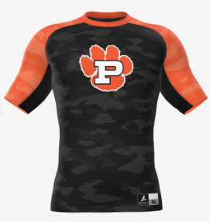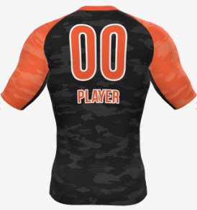

BSN VICTORY COMPRESSION 1/2 SLEEVE
Turn in to Coach Knaus by: June 17
Please make checks payable to Plymouth HS FB.
Name on Jersey: __________________________________________
Number on Jersey: ______ SIZE: ______ (XS-4XL)
Player name: _____________________________________________
Contact email address: ____________________________________

